Step 1: Dev commits changes in SCM
Step 2: Jenkins polls SCM and see changes => Jenkins invoke cmd batch file
Step 3: cmd batch file contains a suite of commands:
First, download the project from SCM
Second, build the project from downloaded files
Third, deploy the project in Tomcat

Fourth, download the test case
Fifth, build the test case from downloaded files
Sixth, run the built test case against the project to verify if the project works or not
From Fourth to Sixth, you can use local test case if you want.
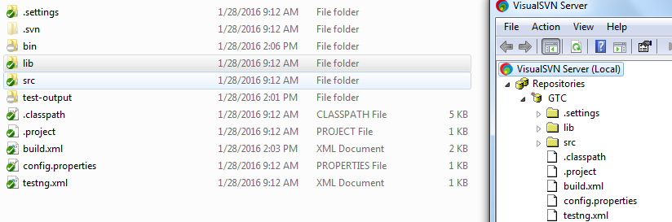

Generate testng reports

We don't need to subversion bin, test-output. The reason is bin and test-output are created after building project.

